CHAPTER 3

ANALYSIS & DESIGN

3.1 Introduction
Chapter explains how the VIDHAN system is analysed, modelled, and architected to achieve its objectives of promoting constitutional literacy through gamified and Chabot-assisted learning.
The design phase provides a comprehensive view of the internal system structure, data flow, UML diagrams, and the algorithms that make the application interactive and intelligent.
The analysis ensures that all requirements are well understood and translated into modular, scalable components for implementation.

3.2 IDEA Matrix
The IDEA Matrix represents the relationship between identified problems, ideas and technologies used to build VIDHAN.
Table No. 3.1 IDEA Matrix
IDEA | Deliverable | Parameters Affected
Simplify the content | User gets simplified version of constitution | Frontend & React UI
Introduce gamified learning experience | Improves motivation and learning retention | React.js, quiz modules
Use interactive, dynamic web interface | Create a modern, responsive platform | React.js, CSS& JS animations
Provide user progress dashboard | Tracks performance and awards badges | MySQL + Spring Boot APIs
Create admin and sub-admin panels | Enables structured content updates | Java Spring Boot backend

3.3 Feasibility Analysis
The feasibility study ensures the system is practical and can be implemented effectively.
Table 3.2 Feasibility Analysis
Type of Feasibility | Description
Technical Feasibility | The system uses open-source technologies (React, Spring Boot, MySQL) that are easy to integrate and scalable on AWS.
Economic Feasibility | Low development cost due to open source stack, hosting and data storage are affordable through AWS.
Operational Feasibility | The web interface is intuitive. Users, Admins, and Sub-Admins require minimal training.
Schedule Feasibility | The project is scheduled to be successfully completed within 24 to 29 weeks following Agile sprint cycles conceptualization.
NP Completeness Analysis:
The VIDHAN system is computationally feasible within polynomial time.
Each module performs finite, bounded operations.
Hence, the system’s operations are P-class problems, ensuring practical computability.

3.4 Architecture Diagram
The system architecture of VIDHAN follows a multi-layered client-server design integrating frontend, backend, Games module, Chatbot, and database modules.
Layers:
- Client_Layer (React.js): The frontend handles user interactions, quiz participation, and visualization of progress.
- Server_Layer (Java Spring Boot): Manages APIs, business logic, and authentication, handles frontend requests routing, handles chatbot interactions and connections to chatbot server.
- Chatbot_Server (AI Model API): Chatbot module processes user queries about the Constitution and gives responses.
- Database_Layer (MySQL): Stores user data, constitutional content, quiz results, and logs.
- Admin_Layer : The Admin manages the Constitutional text data in Database as well as the games, quizzes, daily tasks and facts.
Sub-Admin dashboards manage and update articles, quizzes, and gamified content.

All modules communicate securely through HTTPS using REST APIs and MySQL SDK.
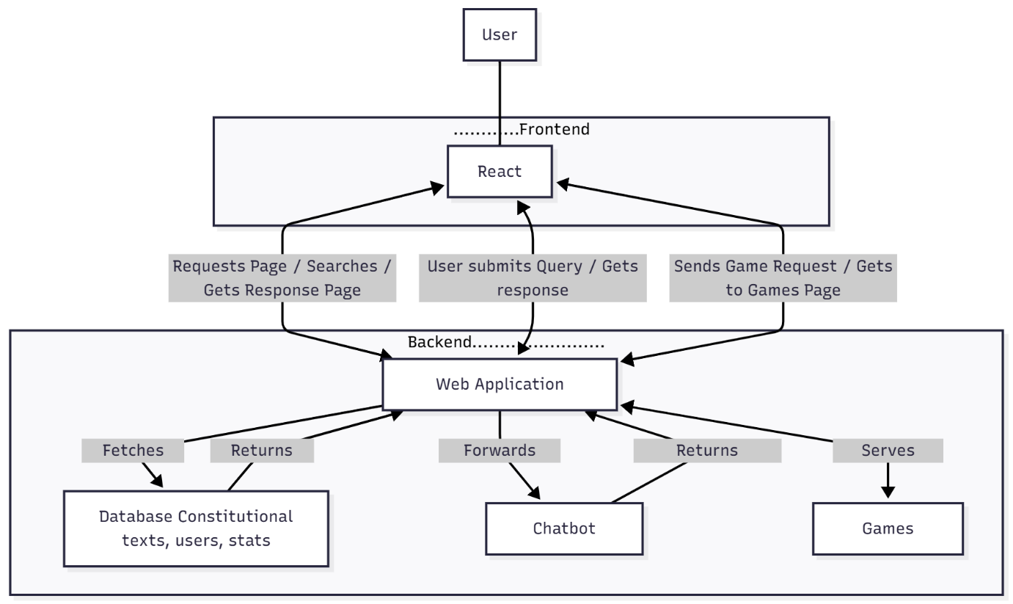
Fig 3.1 : High Level System Architecture
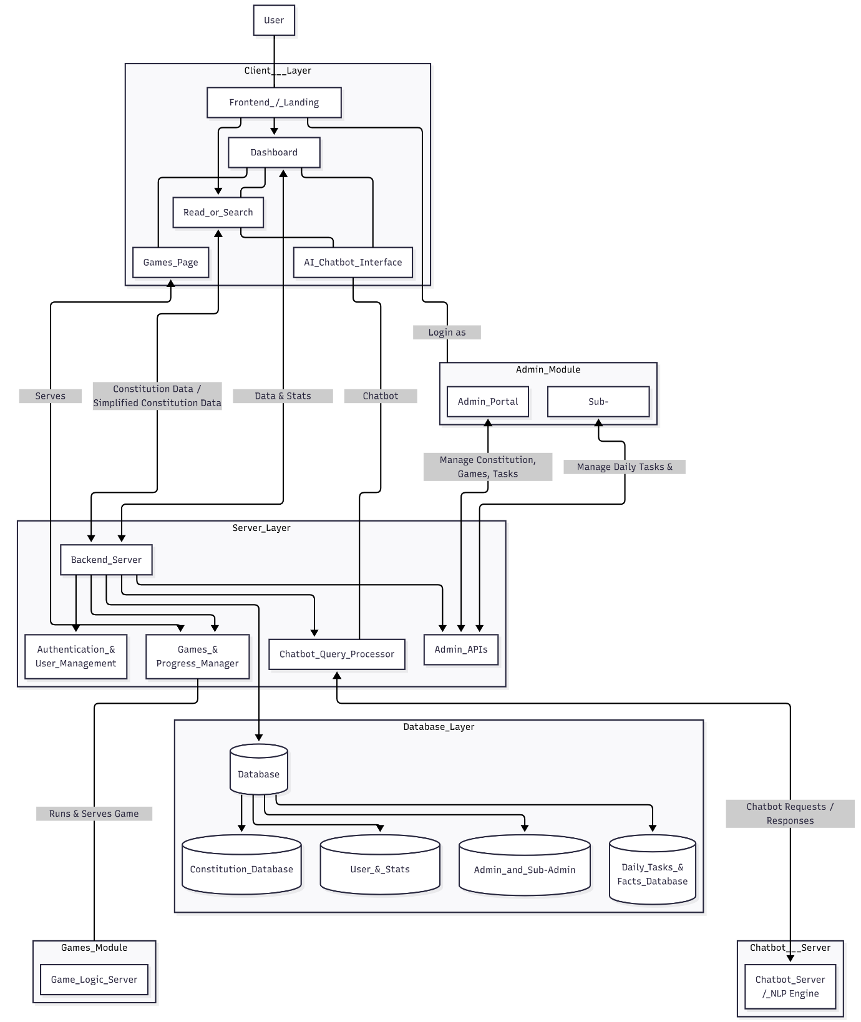
Fig No. 3.2 : System Architecture Diagram

3.6 UML Diagrams
Unified Modeling Language (UML) diagrams represent the structural and behavioural design of the VIDHAN system.
Each diagram illustrates a distinct perspective of system functionality.

3.6.1 Use Case Diagram
The Use Case Diagram represents the functional requirements of the system.
This use case diagram covers the following key functional requirements:
- User registration and authentication
- Chatbot interaction
- Quiz and gamified learning
- Progress tracking and leaderboard
- Admin and sub-admin content management
Actors:
- User
- Chatbot
- Admin
- Sub-Admin
The User performs core activities like logging in, accessing constitution text, playing games/quizzes, and asking the chatbot questions.
The Chatbot assists the user by answering queries and guiding them to relevant articles.
The Admin handles high-level management, including logging in, updating the main constitution text, and monitoring the leaderboard.
The Sub-Admin manages daily engagement content, such as adding or editing quizzes and tasks, and also monitors the leaderboard.

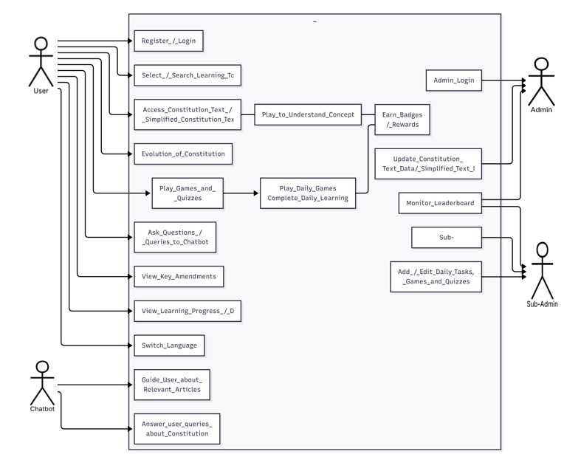

Fig No. 3.3 Use Case Diagram

3.6.2 Activity Diagram
The activity diagram for the project “VIDHAN: A Gamified Approach to Learning the Indian Constitution with AI Assistance” illustrates the complete flow of user interactions and system operations. It captures the behaviour of three main actors User, Admin, and Sub-Admin and shows how each interacts with the system at different stages.
The diagram begins with the User visiting the website. From this point, the user can either read the Constitution directly or choose to register or log in to access personalized learning features. If the user decides to log in, the system validates the user credentials. Invalid credentials prompt a retry, while valid credentials allow the user to proceed to the dashboard.
Once on the User Dashboard, several actions become available:
- Reading Constitution Text: The user can view and read the Constitution, explore its evolution and amendments, or access the simplified version for easier understanding.
- Chatbot Interaction: The user can ask questions to the chatbot. The chatbot processes queries using NLP techniques, fetches relevant articles or simplified explanations, and displays meaningful responses to enhance learning.
- Gamified Learning: Users can engage in games and quizzes related to the Constitution concepts, earning points or badges that encourage continuous participation and application of concepts understood.
- Daily Tasks and Progress Tracking: The user can view daily tasks, facts, and updates. Completed learning activities are saved in the database, and users can review their progress on the dashboard.
parallely, the Admin and Sub-Admin flows manage and maintain the learning system.
- The Admin logs in, validates credentials, and gains access to functionalities such as updating Constitution content, managing simplifications, handling user data, and monitoring progress reports. Admins can also modify learning modules and manage games and quizzes.
- The Sub-Admin has a more limited role, focusing primarily on adding or updating quizzes, games, and learning tasks to keep the content fresh and engaging.
Both Admin and Sub-Admin can log out after completing their respective operations. The entire flow concludes when all user activities (reading, learning, playing, or chatting) are completed and the user logs out.
This activity diagram effectively represents the seamless integration of educational content, chatbot assistance, and gamified learning in a structured flow. It visually demonstrates how different user types interact with the system to achieve the overall goal making constitutional learning engaging, interactive, and accessible to all.
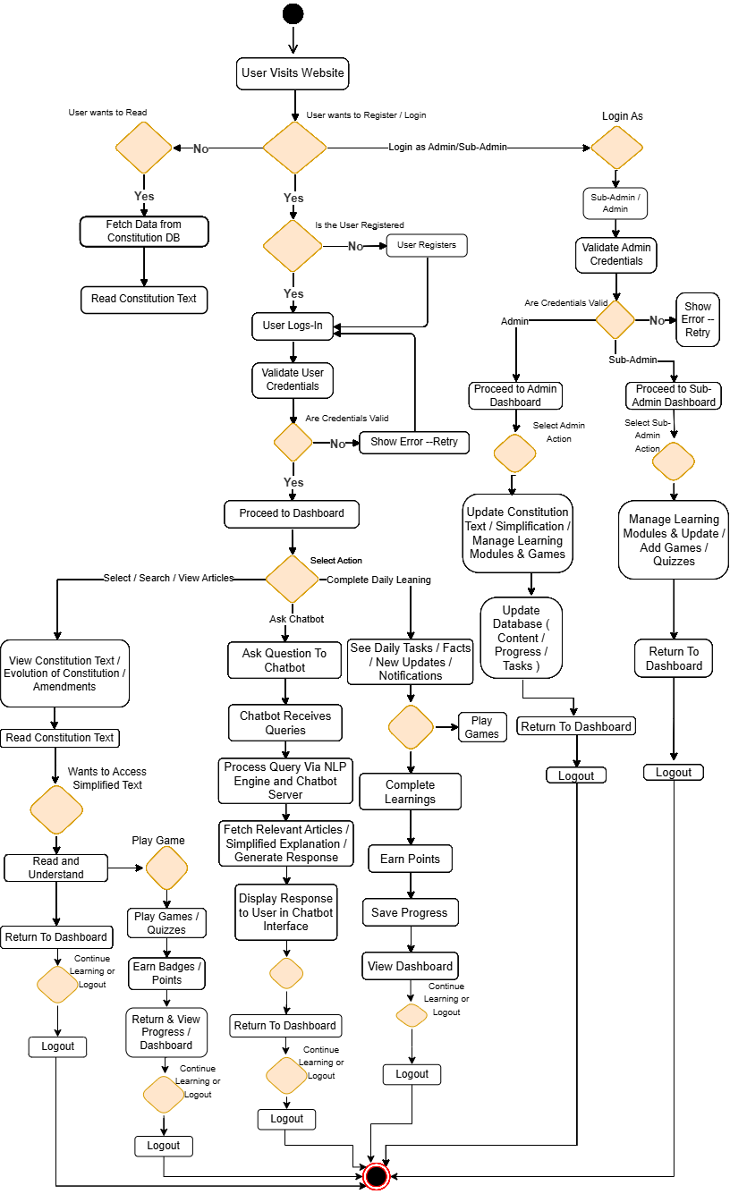
Fig No. 3.4 Activity Diagram

3.6.3 Class Diagram
The Class Diagram illustrates the static structure of the system and defines the relationships among its core classes. It provides a blueprint of how different entities such as users, games, constitutional content, and the Chabot assistant interact within the application. Each class encapsulates relevant attributes and operations that contribute to the overall learning and gamification process.
The system is centered around the User class, which represents learners, administrators, and sub-administrators using the platform. It contains attributes such as userId, username, email, and role, and provides key operations like login(), logout(), and search() for authentication and navigation within the system. Each user is associated with a ProgressTracker, which maintains learning statistics, completed articles, and quiz or game performance. The ProgressTracker class records user progress through attributes such as completedArticles, gameScores, and quizScores, and provides methods like trackArticle(), updateGameScore(), and updateQuizScore() to monitor engagement.
The ChatbotAssistant class supports intelligent assistance within the system by handling user queries and providing simplified explanations of constitutional concepts. It includes operations such as answerQuery() and summarize(), which enable personalized guidance.
The Constitution class represents the structural foundation of the system’s learning content. It contains attributes such as title and preamble, and provides methods like getArticle() and getPart() to retrieve specific sections. The Constitution is further divided into Parts, Schedules, and Articles, each modeled as separate classes.
- The Part class contains attributes for part number, title, and description, and links multiple related articles.
- The Schedule class includes attributes like scheduleNumber, title, and contentText, representing the constitutional schedules.
- The Article class contains key attributes articleNumber, title, and contentText, with operations like display() and getHistory() to present and trace article information.
Amendments and historical evolutions of the Constitution are captured by the Amendment and Evolution classes respectively.
- The Amendment class records constitutional changes with attributes like amendmentNumber, year, and description, along with a getAffectedArticles() operation to identify impacted articles.
- The Evolution class stores information about textual changes or updates over time, with attributes such as changeId, description, and effectiveDate.
To make learning interactive, the system incorporates gamified components represented by the Game and Quiz classes.
- The Game class manages game sessions with attributes such as gameId, type, and difficulty, and includes operations like start() and end().
- The Quiz class, linked to both the Game and User, includes attributes like quizId, topic, and questions, and methods such as start() and submit() to facilitate assessment-based learning.
- Both classes interact with the ProgressTracker to record user achievements and performance metrics.
The diagram also illustrates several associations and multiplicities among classes:
- A User is associated with one ProgressTracker, multiple Games, and multiple Quizzes.
- The Constitution aggregates multiple Parts, Schedules, and Articles.
- Each Article can be linked to several Amendments and Evolution records.
- The Chatbot Assistant interacts directly with the User and the Article classes to provide contextual explanations and summaries.
This class diagram effectively models the object-oriented architecture of the Constitution Learning Website, ensuring modularity, reusability, and scalability. It captures both the content management aspect (through Constitution, Article, and Amendment classes) and the learning engagement aspect (through Game, Quiz, ProgressTracker, and ChatbotAssistant classes). Together, these interconnected components enable a seamless and interactive learning experience for users exploring the Indian Constitution.

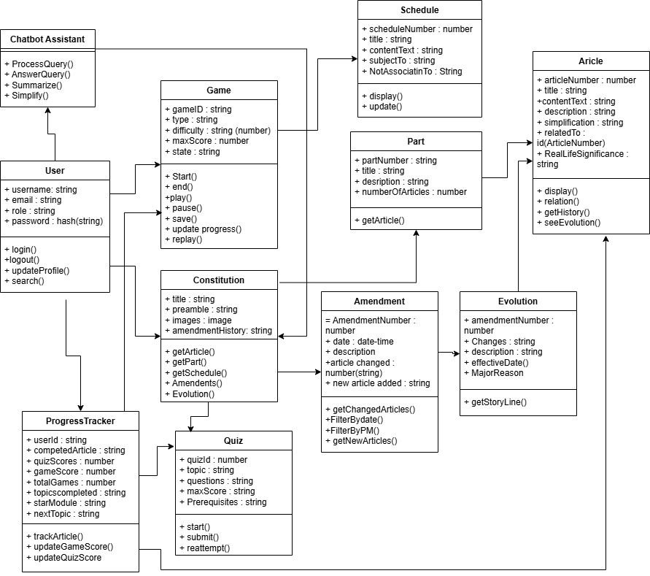
Fig No. 3.5 Class Diagram
Major Classes and Responsibilities:
Fig No 3.3 : Major Classes and Responsibilities
Class Name | Attributes / Methods | Responsibility
User | userId, username, email, role, password | Handles authentication and user profile
Games | gameID, type, difficulty, state, maxScore
Quiz | quizId, topic, questions, maxScore, Prerequisites | Manages quizs and scoring
Chatbot Assistant | answer(), process(), simplify() | Handles Chatbot query processing
Constitution Article | articleId, title, contentText, amendments, related | Stores and retrieves constitutional text
Progress Tracker | progressId, scores, badges | Tracks user learning progress
Admin | adminId, manageContent() | Manages user and content data
Sub-Admin | subAdminId, updateQuiz() | Handles quiz updates and tasks

3.6.4 ER Diagram
The ER Diagram models the relational database design of VIDHAN.
Key Entities:
- User (userId, username, email, password)
- Quiz (quizId, topic, questionSet)
- Score (scoreId, quizId, userId, marks)
- Article (articleId, partNo, content)
- Admin (adminId, name, email)
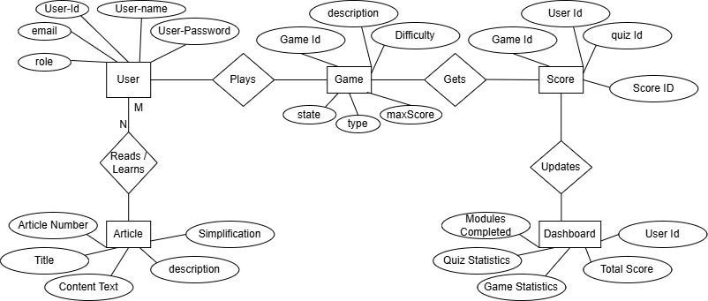
Fig No. 3.6 Entity Relationship-1 Diagram User Flow

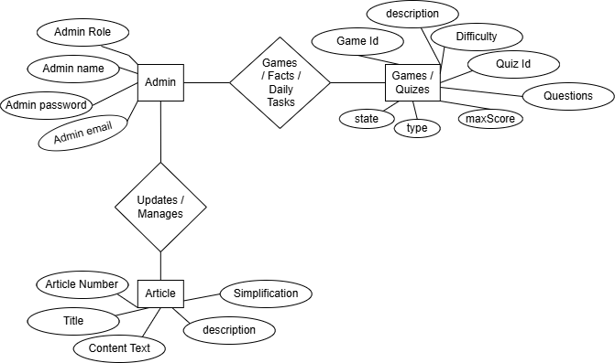
Fig No. 3.7 ER-2 Admin Flow Diagram

3.6.5 Sequence Diagram
The sequence diagram provides a detailed overview of how the User, Web Application (Browser), Web Server (Backend), Database, and Chatbot Service interact across three main scenarios searching for articles, taking quizzes, and interacting with the chatbot.
The diagram captures the dynamic message flow between components, emphasizing the logical order of operations, data retrieval, and response mechanisms that enable smooth learning experiences on the platform.

Scenario 1: User Searches for an Article
This scenario highlights how the user can access any constitutional article quickly through an efficient search mechanism, powered by backend querying and real-time rendering.
- The User enters a search query (e.g., “Article 14”) in the web app interface.
- The Web App (Browser) sends a GET /search?q=Article14 request to the Web Server.
- The Web Server queries the Database using an SQL statement like
SELECT * FROM articles WHERE title LIKE '%Article 14%'.
- The Database returns the relevant article data to the Web Server.
- The Web Server responds with a 200 OK message containing the article content in HTML or JSON format.
- The Web App renders and displays the retrieved article for the user.

Scenario 2: User Takes a Quiz
This flow demonstrates the gamified learning system, where users participate in quizzes to reinforce their understanding of constitutional concepts and track their progress.
- The User clicks on the “Start Quiz” button to begin a quiz session.
- The Web App sends a GET /api/quiz/questions request to the Web Server.
- The Web Server fetches a predefined set of quiz questions from the Database using
SELECT * FROM quizzes LIMIT 10.
- The Database returns the quiz questions and answer options to the server.
- The Web Server responds with a 200 OK status, sending the quiz data back to the Web App.
- The Web App displays the first question, and the User proceeds to answer each one.
- For each question, the selected answers are submitted via POST /api/quiz/submit.
- The Web Server calculates the quiz score based on the submitted answers.
- The results are stored in the Database using
INSERT INTO quiz_results (user_id, score).
- The Database confirms the successful storage of quiz results, and the Web Server responds with a 200 OK message containing the final score.
- The Web App displays the final results page to the User.

Scenario 3: User Interacts with the AI Chatbot
This scenario illustrates the AI-powered learning assistance, where the chatbot leverages NLP and AI to simplify complex constitutional articles and provide personalized guidance to learners.
- The User types a question, such as “Explain Article 21”, into the chatbot interface.
- The Web App sends a POST /api/chat request containing the message to the Web Server.
- The Web Server initiates Step 1: Retrieval, searching the Database for relevant text or context related to “Article 21”.
- The Database returns the relevant section or article text.
- The Web Server performs Step 2: Augmentation & Generation by constructing a context-enhanced prompt and sending it to the Chatbot Service.
- The Chatbot Service processes the request, generates a natural-language explanation, and returns it to the Web Server.
- The Web Server responds with a 200 OK message containing the AI-generated answer.
- Finally, the Web App displays the chatbot’s response to the User in the chat window.
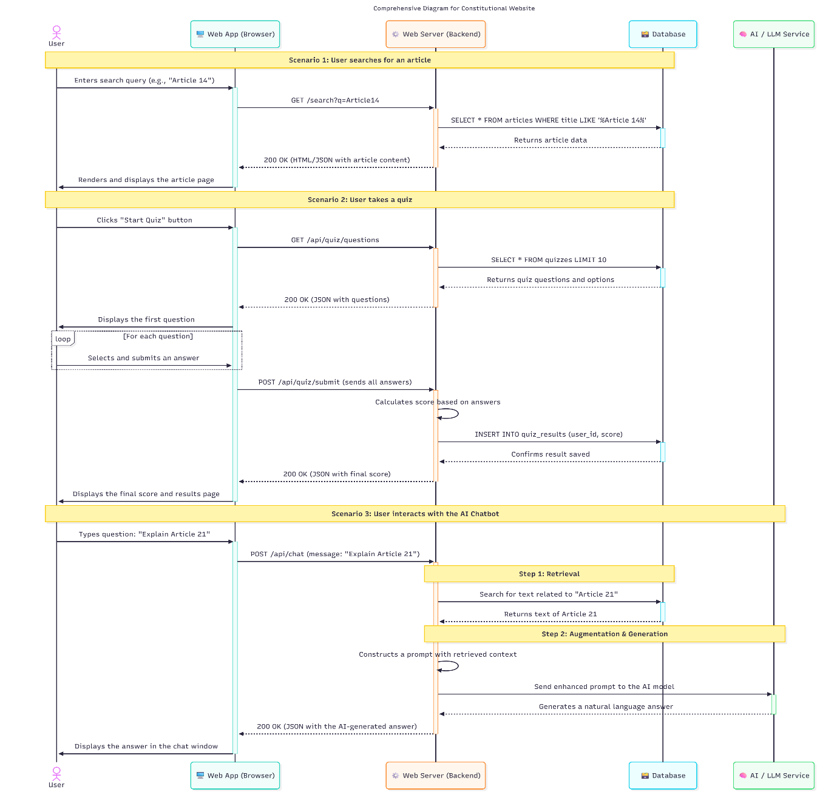
Fig No. 3.8 Sequence Diagram

3.6.6 Deployment Diagram
The Client Machine hosts the web interface built using React.js, which communicates securely with the Backend Server via HTTPS. The Backend Server, implemented using Spring Boot, contains key modules such as the RESTful API controllers, authentication service, quiz and leaderboard management, and database access layer.
The Chatbot Server, powered by Python (Flask - TBD) and trained NLP models, communicates with the backend using HTTPS/JSON over REST to provide AI-driven responses to user queries. Similarly, the Games Server handles all game-related operations like logic, scoring, and visuals, and exchanges data with the backend securely.
The Database Server (MySQL) stores all persistent data, including user profiles, quiz scores, constitutional articles, progress tracking, and game data, connected via a JDBC/MySQL connector.
Nodes:
- Client Machine (Web Browser)
- Application Server (Java Spring Boot)
- Chatbot Server (API, Python)
- Database Server (MySQL)
- Games Server (Java , React Game Engine)
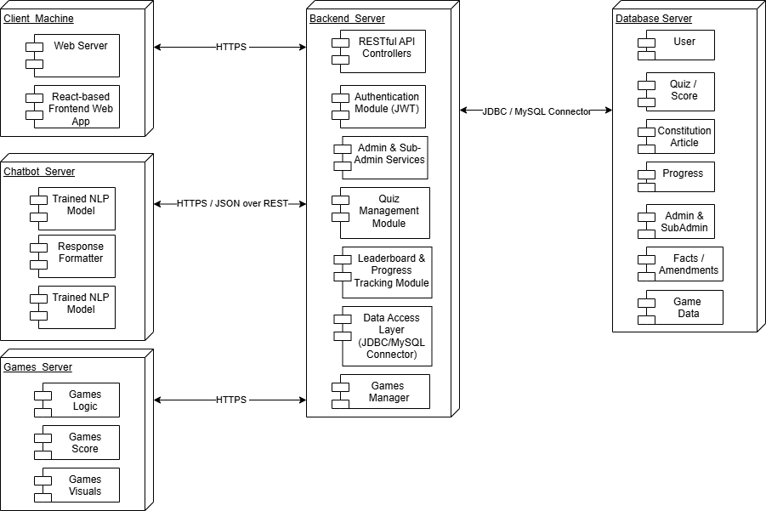
Fig No. 3.9 Deployment Diagram

